JANUARY 2017
AVATAR VANI
PERFORM ALL ACTIONS WITH
DIVINE FEELINGS

When man emerges from the womb of his mother, one does not find any garland around his neck. There are no jewels made of pearls nor are there glittering gold ornaments. There are no necklaces studded with precious stones like emeralds and diamonds. But there is one garland around his neck. Brahma strings together the consequences of his past deeds into a heavy garland and puts it around his neck at the time of his birth.
(Telugu Poem)
SACRED ACTIONS HAVE SACRED RESULTS
Embodiments of Divine Atma!
Whatever good or bad, man experiences in life is the consequence of good or bad actions performed by him. He can see the action performed by him, but may not observe its consequence immediately. There may be a time gap between the action and its consequence.
Make your Present Sacred and Sublime
However, there is no separation between action and the consequence; the consequence is intertwined with the action. When we are hungry, we eat food to satisfy our hunger. But there is a time gap between the action of eating and digestion. After we put the food in the mouth, it goes to the stomach and gets digested. A period of two hours is required for the digestion of the food. Then only will the food give strength and nourishment to the body. Similarly, there may be a time gap between actions performed by man and its consequences.
A seed does not become a tree as soon as you sow it. The seed first germinates, becomes a sapling and then grows to become a tree in due course of time. The entire tree is within a tiny seed. However, man sees only the seed, not the entire tree hidden in it. Similarly, man’s future is contained in the actions performed by him in the present. Man wants to know his future and waits for it. But there is no need for him to wait for it as his future lies in his present. It is his present that determines his future. Therefore, man should make his present sacred, sublime and purposeful.
A student writes the examination in the examination hall, but he waits for a month or two for the result. But it is not necessary for him to wait for two months to know his result. His result lies in the way he has written the examination. Similarly, one who does good actions will never have bad results. On the other hand, if one does all wrong deeds, one cannot aspire to have good results. Sowing the seed of a neem tree, can you have a mango fruit? As is the seed, so is the fruit.
Everyone should be prepared to undertake sacred actions so as to receive good results and thereby lead a sacred life. But man should not have body attachment. What kind of stuff is this body? If you take a closer look, you will find that it is a skeleton of bones filled with flesh and filth. Every moment it emits foul smell, and no fragrance. When we put rice in the flour mill, we get rice flour. If we put wheat in it, we get wheat flour. As is the material you put in, so is the flour you get. Human body is also like a flour mill. But if you put fruit in it, it gives out foul smelling excreta. Human body is thus much worse than an inert machine. If you eat a little pickle in the morning, it will be digested by the body and change into excreta in the evening. But the same pickle, when you put it in a jar, it will remain fine for a year. So, body is worse than even a jar.
Indweller Atma Gives Value to Body
But this body contains the sacred gem of Divinity just like precious jewels are treasured in a cheap iron safe. Man should know that God is present in the body as Atma. Iron safe is not valuable, but jewellery kept in it is highly valuable. Body is like a valueless iron safe in which God has put valuable jewels of good qualities. You purchase the iron safe to keep valuable jewellery in it. If you don’t have valuable jewellery, you don’t need the iron safe. Similarly, we have to take care of this valueless body because of valuable qualities in it. This valueless body contains valuable Atma. We have to protect the body for sake of the Atma present in it. Body is a temple of God. That is why the scriptures say: Deho Devalaya Proktho Jivo Deva Sanathana (the body is a temple and the indweller is God). We get thrilled looking at the temple, but we do not make an attempt to see God in the temple. You may build a vast and beautiful temple with marble stones. But, who will go to the temple if the idol of deity is not installed in it? So, temple is not important, the idol of God in it is important. Similarly, body is not important. What is important is the Atma which indwells it. Without the Atma, no one will keep the body in the house even for a moment. It is a dead body. How long is the body a temple? So long as God in the form of Atma is present in it. It is called Shivam (auspicious) when Atma is present in it. When Atma leaves it, it becomes Shavam (dead body).
So long as there is life in the body, it is Shivam; when the life is gone, it is Shavam. No decay affects it so long as there is life breath in it; it can be sustained even up to 80, 90 years. When life breath goes out of the body, it starts decaying within one hour and starts emitting foul smell. No one will keep the dead body in the house, not even those who have given birth to it. The wife who spent all the 24 hours enjoying the company of her husband will be frightened to look at his dead body. Why is she afraid of that? She is afraid because there is no Shivam in it. So as long as Shivam is there in it, she protects it and feels very happy to see it. When the life is gone, she does not even want to look at it. What is this relationship? What is true love? Who are the true relations? Take time to recognise this.
God is Closer to you than your Relations
A twenty years old son loves his mother very much. She is so much dear to him. After some time, the mother dies. He then sits close to her dead body and wails, “Mother, I relied on you for such a long time. You only protected me and fostered me. Who is there to take care of me now? Mother, why have you left me”?
Who is the one that has left? Truly, if the body is the mother, the body is there. Who says it is gone? What really has left? It is only the Jiva, the individual soul. The son loves his mother because Jiva is present in her. The moment the individual self is lost, the same son cremates the body of the mother without any compassion. Who is the true mother? Who is the one that has left? It is only the Jiva. Then who is the mother? Jiva is the mother. When there is no Jiva, nobody will respect the body. Hence, who is the true mother? That is God! God is the mother. God is the father.
More than your mother, God is nearer to you. More than your father, God is closer to you. It is a great sin to forget God. The word of Sai is the word of truth. (Telugu Poem)
You may have close proximity with your mother; she may be close to the body, but God is within your body. So, God is much closer to you than your mother. You should never forget God who is closer to you than the closest. God is responsible for the whole creation. God is the ideal for your life. God is your very breath. We should always remember, worship and follow Him at all times.
Body is just an instrument, which should be put to proper use. When the instrument is in good condition, you can perform all tasks with it. If you want to dig a pit, the crowbar you carry should be sharp and pointed. If the crowbar is not sharp, you can never dig the pit in spite of all the strength of your hands. When your own power joins the power of the instrument, the expected pit can be dug well. When human effort is combined with God’s grace, it is possible to perform any task.
Do all Actions to Please God
Karmanubandheeni Manushya Loke (man in the world is bound by action). Man is bound by action; he is sustained by action. He can achieve anything through action. His accomplishment lies in his skill in doing actions. All actions can be accomplished with divine power. Whatever actions man performs, he will have equal and appropriate consequences. He cannot escape the consequences of his actions. Man may leave the world at one moment or the other, but the consequences of his actions will not leave him; they will follow him. So, we should do good actions, develop good thoughts and join good company. Only then will we get good reward in future. As is the seed, so is the tree. As is the tree, so is the fruit.
You should engage in doing good actions right from early age. What are good actions? The actions that please God are good. When you do actions that please God, you will also have the reward that will please you. On the contrary, if you do not perform pleasing actions, you will never have pleasing reward. That is why it is said, Sarva Karma Bhagavad Preetyartham (do all actions to please God). When you offer all your actions to God, your heart will become sacred. With the sacred heart you can lead a peaceful life. You should have a strong determination to keep your heart sacred. This strong determination requires three P’s. The first P is Purity; the second P is Patience and the third P is Perseverance. We should always observe Purity, Patience and Perseverance in life. Observance of these three qualities will make our life sacred.
Embodiments of Divine Atma!
All your actions should be sacred and noble. Unsacred actions give unsacred results. Don’t make haste. Start early, drive slowly and reach safely. Enquire peacefully and perform all actions without haste. People get into many troubles due to haste. So, don’t be in haste; it is not good. Haste makes waste. Waste makes worry. So, do not be in a hurry. Control this haste.
Whatever may be the task you undertake, better you weigh its pros and cons before performing it. Do not be in a haste, for haste will only lead to worry. (Telugu Poem)
Never make haste. If you are hasty, even Amrita (nectar) becomes poison. Start all actions with peaceful feelings. Enquire whether it is good or bad, right or wrong. Exercise your discrimination. All actions done with divine feelings will give good results. But man today has no consideration for divine feelings. He indulges in mean pursuits and ruins his precious life. When we do actions peacefully with divine feelings, then our life will be full of peace and happiness. Consider every action sacred and valuable. Enquire deeply before performing any action. Make God’s Name as the basis of everything you do. God’s Name will change even unsacred actions into sacred ones.
– Bhagavan’s Discourse in Sai Sruthi, Kodaikanal on 22nd April 1993.
JOYOUS CHRISTMAS 2016
A large number of devotees came to Prasanthi Nilayam from more than 35 countries to celebrate the holy festival of Christmas in its sacred precincts. The theme of this year’s Christmas celebrations was: “Love: Living our Values Everyday”. The entire township of Prasanthi Nilayam bore a festive look with beautiful Christmas decorations on this occasion. The decorations in Sai Kulwant Hall, the venue of the celebrations, included Christmas trees, Christmas stars, giant portraits of Lord Jesus and Bhagavan Baba, flowers, festoons and banners which beautifully depicted the main teachings of Bhagavan Baba and Lord Jesus. The entire Ashram was beautifully illuminated at night, and there were attractive illuminations on Yajur Mandir, Sai Kulwant Hall and other buildings. An international team consisting of nine countries arranged all exquisite decorations in the Ashram. The three-day celebrations held on 24th, 25th and 26th December 2016 comprised carol singing, devotional songs, musical presentations and talks by eminent speakers.
International Adults Choir
The first presentation of the celebrations was International Adults Choir performed by about 400 singers and musicians in Sai Kulwant Hall on 24th December 2016. Beginning with a song dedicated to Lord Ganesh “Mangalam Ganesha”, at 5.00 p.m., the singers presented in all 18 Christmas carols and devotional songs which included “Christmas in Prasanthi”, “Oh Come all ye Faithful”, “Wonderful Merciful Saviour”, “My Sweet Lord” and “Hallelujah”. Perfect synchronisation of music with melodious and soulful singing of the singers surcharged the entire milieu with devotion and brought alive the true spirit of Christmas. The choir was conducted by Ms. Tanja Goldberg from London.
Christmas Programme by Students
On the sacred Christmas day, 25th December 2016, the programme started early in the morning at 6.20 a.m. with singing of Christmas carols celebrating the birth of Lord Jesus by a group of devotees, both ladies and gents, led by musicians from the International Choir. Beginning with “Oh Come all ye Faithful”, the singers sang in all nine Christmas carols which included “We Three Kings”, “Jingle Bells”, “Silent Night”, “The First Noel”, “What Child is this” and “Joy to the World”.
The next programme began at 8.30 a.m. with a sterling Christmas presentation by students. First, the students of Sri Sathya Sai Primary School gave a thrilling recital of Christmas carols on their violins followed by an equally enrapturing presentation by the brass band of Sri Sathya Sai Institute of Higher Learning. What came next was an insightful presentation by students comprising dialogues interspersed with thematic songs, depicting the significance of Christmas celebrations. The beautiful songs presented by the students included “Shout to the North and South”, “Love, I Offer my Life to you”, “Use me Today I Know You Can”, “Jingle Bells” and “Where You Go I will Go”. As the singers sang “Jingle Bells”, students dressed as Santas went into the rows of devotees in the hall and distributed chocolates to the joy of one and all. Bhajans followed next and concluded with Arati at 10.00 a.m.
A Classical Music Recital
The programme on the afternoon started at 5.00 p.m. with a very illuminating and inspiring talk by Ms. Capaya Rodriguez, Ambassador of Venezuela to Philippines and a former National President of Venezuela, Sathya Sai International Organisation. Narrating how she came to the fold of Sai, the distinguished speaker described her experiences of Bhagavan’s Divinity, hailing Him to be the Ultimate Supreme Reality and stating how He guided her at every step in her life.
The next item of the programme was a classical music recital by an accomplished pianist Ms. Johanna Maurer-Brzezinska accompanied by Klaus Maurer on violin and Ruben Barros on clarinet. Beginning their presentation at 5.00 p.m., the musicians kept the audience mesmerised for more than half an hour with recital of famous compositions of renowned musicians, viz., Schubert, Chopin and Bach on piano, violin and clarinet.
Bhagavan’s Divine Discourse
Divine Discourse of Bhagavan followed next, a video clip of which was shown on the big screen in the hall. In His Discourse, Bhagavan described how Jesus helped the poor and needy and never left his compassion in spite of all the sufferings borne by him. Jesus, Bhagavan said, taught the lesson of love, compassion, sacrifice and service. Bhagavan exhorted the devotees to follow these teachings of Jesus. He brought His Discourse to a close with the Bhajan “Prema Mudita Manase Kaho Rama Rama Ram” which the devotees in the hall followed in chorus with deep devotion. Bhajan followed next and concluded with Arati at 7.00 p.m.
International Children’s Choir
The programme on 26th December 2016 began at 5.00 p.m. with a short speech of Sri Tom Lahey, Chairman of the Christmas Committee, Sathya Sai International Organisation, who offered gratitude to Bhagavan for this unique opportunity to celebrate Christmas at Prasanthi Nilayam and thanked the Central Trust and devotees of various countries who helped in making the celebrations a grand success. This was followed by a talk by a long standing devotee of Bhagavan, Sri Ladd Bogdonoff from Northern California, U.S.A., who narrated how Bhagavan came to his rescue when he was in a helpless situation, and how Bhagavan removed his doubts and guided him to the path of spirituality and divinity. He concluded his talk with a song “We are Standing on Holy Ground”, with enthusiastic participation of devotees.
The grand finale of the Christmas celebrations was a captivating devotional music programme presented by the Children’s Christmas Choir consisting of about 70 children. Beginning their programme with a Sanskrit prayer for the good of all “Sarvesham Swastir Bhavatu”, the children in all presented 14 Christmas carols. As the carol singing began, a Children’s Nativity Procession came forward which was the object of attraction for all. The songs rendered by the children included “Song of Kings”, “Brother Son Sister Moon”, “Carol of the Bells”, “He Reigns Forever” and “All is Well”. Melodious rendition of the songs supported by sweet music touched the hearts of one and all. Excellent video support, illustrating the Christmas story made the programme all the more attractive. The choir was ably conducted by Ms. Gesine Strohmeier from Germany.
GOOD QUALITIES ENSURE PEACE AND PROSPERITY
Where there are the six qualities of enthusiasm, courage, bravery, devotion, energy and valour, there manifests Divinity.
(Sanskrit verse)
Students! Embodiments of Love!
In any field, at any time, for any man who is endowed with all these six precious qualities, success is assured. These qualities contribute to the all-round prosperity of a man. All success attends on one with these six qualities.
Develop Self-confidence
However, these qualities confront various difficulties from time to time. Just as a student has to face various tests, these qualities are also subject to trials. Such trials should be regarded as stepping stones to one’s high achievements. These trials are in the form of losses, troubles, pains, sufferings and calumny. One has to overcome these troubles with courage and self-confidence and go ahead. Students in particular have to develop self-confidence. Without self-confidence these six qualities cannot be acquired. In fact, self-confidence should be the life-breath of every person. Unfortunately, students today lack self-confidence and become prey to restlessness because of their involvement in sensual pleasures.
Students should cultivate self-confidence and manifest their divinity in their speech, their songs, their sports and all actions. However, occasionally the weakness in them may come out. For instance, when they succumb to troubles, are overcome by grief and are unable to face losses, they show their inner weakness. Students should confront such situations with fortitude. Be fearless. When you face difficulties with courage, you are bound to succeed. Hence, have confidence in yourself and achieve success in all areas of life.
Good Qualities Enable one to Lead a Good Life
Self-confidence is helpful to secure advancement of the individual, but it is not enough to promote the welfare of the society or the world. A whetstone is used for sharpening the razor and not for making the stone smoother. Similarly, good qualities have to be fostered for refining one’s nature. These qualities are essential like the different limbs in the body for its well-being as a whole. People should realise that human birth has been given to them to lead ideal lives. Good qualities enable one to lead a good life. But even for the good life a price has to be paid. That price is good conduct. This means that you derive the happiness that results from a good life only when you discharge your duties. Happiness is of two kinds: temporary and lasting. Permanent happiness can be got only by performing your duties. First do your duty and then enjoy the fruits. Today people do nor discharge their duties but wish to enjoy the fruits thereof. This cannot give them happiness.
Everyone should realise that he is born to discharge various obligations and not to enjoy rewards for unrendered services. Man should realise that he has no claim to rights. His role is to carry out his duties. When he performs his duties, he will reap the rewards in due course. People today do not discharge their duties but fight for their rights.
Students!
At the outset, realise your duties and carry them out. Duty is God. Work is worship. It is foolish to expect rewards without performing one’s duties. People are wasting their sacred human birth by neglecting their duties. Students should realise that neither youth nor wealth nor wife nor children are permanent. Only truth and righteousness are everlasting. You must base your lives on truth and righteousness and should be prepared to face any challenges with courage and confidence.
Five Advisers in Everyone’s Life
Everyone has five advisers in life. They are: who, when, where, what and how. Before undertaking any action, answers should be got for these five questions. When the correct answers are got, the actions based on them will be right. People today act without concern for these factors. In this matter, everyone can rely on his own judgement using his powers of observation and discretion. All the instruments for this purpose are available to everyone in his organs of perception and action. In every limb and organ, there is divine power. This divine potency is called Angirasa. The name is derived from the fact that the Divine is present in every Anga (limb) as Rasa (essence). There is no need to search for the Divine outside. You are Divine. All your powers are Divine potencies.
Develop the conviction that whatever happens to you is for good. Education is not solely for a living. Essentially it is a process of Self-realisation. Without understanding one’s own Self, how can one understand the world or achieve anything worthwhile? Without Self-knowledge what is the Vijnana (scientific knowledge) one can acquire? What is the value of scientific knowledge without wisdom? Hence, one should acquire, along with scientific knowledge, discriminatory wisdom and Atma Jnana (knowledge of the Self).
Significance of Bharatiya Festivals
All Bharatiya festivals have esoteric significance. They have a deep spiritual meaning. Today’s holy festival is related to the beginning of the Uttarayana (northward movement of the sun). The sun moves every month from one house of the zodiac to the next. Today the sun enters the house of Capricorn (Makara) and hence it is known as Makara Sankranti. This auspicious day heralds the conferment of many worldly and spiritual blessings on man. The Sankranti day is a witness to the prospective successes of man in many fields. The advent of Sankranti is glorified in a song which describes how farmers greet the sun and celebrate the gathering of harvest and enjoy the fruits of their labour.
Samyak Kranti Iti Sankranti (Sankranti heralds a welcome change). Sankranti confers peace and heralds a welcome change. It brings about the inner joy in people. It effects a change in the lifestyle. It generates sacred thoughts.
People today do not recognise these sacred changes. They are all immersed in worldly acquisitions and have no regard for higher things. They should instead seek every opportunity to cultivate six good qualities as mentioned at the beginning of the Discourse. Where these qualities are present, there will be no room for any bad tendencies to develop.
Get Rid of Envy and Hatred
Today students suffer from two bad qualities which are undermining their humanness. These are Asuya (envy) and Dwesha (hatred). These two are partners in evil. They are twin pests. A beautiful tree with rich foliage can be destroyed by pests operating at its roots. Envy is such a pest. It converts even a happy, affluent person into a miserable being. In the Mahabharata, Krishna described to Arjuna how the Kauravas were consumed by envy towards the Pandavas even though they were enjoying the kingdom. The demon of envy had seized hold of a good royal family and was ruining it.
Students feel envious towards a boy scoring good marks. Envy rears its head when a boy is exceptionally intelligent. Some feel envious seeing a person who is well-off and happy. Some tend to be envious of those who appear to be cheerful and confident. Envy has no limits. Students should see to it that they give no room to envy. Envy is a self-consuming malady. It is incurable. One who is always blissful will overcome all difficulties. The courageous man can face even death without fear.
Students!
The first and foremost thing you have to observe is respectfulness. This is the essence of education. Cultivate reverence and behave without pride and ostentation. Give no room to jealousy. Do not feel envious when someone is better than you in scoring marks or in sports.
Today is a sacred festival day. It is a day for the celebration of plenty and prosperity. This day of Sankranti brings with it an abundance of crops and wealth. This Pushya month brings with it cool breeze, bright sun, golden fields and trees echoing the songs of birds. The earth shines in the glory of Nature. People admire the beauty of Nature, but are not aware of the beauty in their hearts. Make your heart beautiful by adorning it with the sacred love of God.
– Excerpted from Bhagavan’s Sankranti Discourses.
NEW YEAR GREETINGS
Now, meditate on God,
Earnestly search thy heart,
Wipe out all selfishness.
Yearn only for the Imperishable,
Enter His Kingdom even today,
Aim for the highest good to all,
Righteously deal with all.
Go in the straight though narrow way,
Remember always thy Divine heritage,
Embrace all people in thy love,
Endeavour to think only pure holy thoughts,
Turn now thy gaze within thine own heart,
In serving humanity thou servest God,
Never despair though sorrows assail,
God is above, below and around,
Save thyself first, then the rest of the world.
With Blessings,
SRI SATHYA SAI BABA
(Sanathana Sarathi: March 1958)
SAI – SIMPLE ANECDOTE OF INSPIRATION
Sai Kaustuv Dasgupta
Swami has made me realise the beauty of pain as it comes with a surprise of joy in the next moment. We should do 100% surrender to receive His divine gift. And if we could do that once, our life will be transformed fully. If we could live each moment with Bhagavan’s love, then it will be called a True Sai Living.
Mysterious is what life seems to be and time seems too short for us to enjoy our life fully. Most of us were often told to live life fully but we were never told how to do so. After coming into Sai’s fold, we can realise that our life is very valuable and precious. But are we really aware of Bhagavan’s immense blessings in our life? We are nothing without His grace. But to receive His grace, we need to connect with Him. How can we connect with Sri Sathya Sai Baba after His physical departure or Maha Samadhi? How could we explore this heart to heart connection with Him?
I always believe that we are all connected to Him from our previous births just as children connect with their mother from her womb itself and this connection will continue in future also. He is Omnipresent, Omnipotent and Omniscient. He is the indweller of our hearts. If we try our best, we could still have His Divine Darshan in our inner altar. He is waiting for our call. He is more concerned about our Availability than our Capability. But are we really available for Sai? Besides this, if He is Omnipresent, where could He go? He is still here among us as our life force. We have to cherish each and every moment in our hearts as these moments are blessed by Hridayanivasi Sai. We should follow His guidance in each step of our life to make it more precious. We have to make Sai our dearest friend and treat Him like that only. That is the best way through which we can make our life His Message.
First Divine Glance of Bhagavan in 1996
I had Bhagavan’s Darshan for the first time in 1996 when I was just five years old. I had come twice that year with my parents in the months of July and December. In the month of December, we came for Prasanthi Seva and had an amazing experience. To me He was a wonder man. My moments of thrill came during the Padanamaskar session when I was able to touch His robe, and that first experience thrills me even today. Besides touching His feet, my most thrilling moment came when He patted me on my cheek and ran His Divine hand through my hair. I realise now that right then He chose me to spread His Divine Love and universal message. I was too young to realise it at that time. I was too immature to realise who Sai actually is. Time goes on. After 20 years now I know a little about Him. As knowing and understanding Him fully is not possible in one lifetime, better not to try it. But if you ask me now after 20 years to define Sai, I have a wonderful answer. Sai is my Life!
My Journey towards Radio Sai
When we came to Parthi in the year 2004, I gradually started developing interest in graphic designing after completing my Intermediate. But Swami’s tests are my daily routine. It was so difficult to find a solution of learning designing from home. So, by praying continuously, I got one brother who helped me to learn the basics of designing. After seven days of learning, he showed me a picture of Swami in my desk and told a profound thing: Swami is the Universal Graphic Designer and He will guide you further. I was praying in my mind, “Swami, I will prove what this brother told me, and I will be Your graphic designer one day. I will make You proud with my designs”. After that, I started self study and started learning designing online. I had Swami’s last Darshan in 2009 and after that I was fully confined to my room till 2015. I was not in a position to come out to our balcony too. I used to work on my laptop and see the world through internet all 365 days. With knowledge thus gained, I offered my first wallpaper to Radio Sai team as a heartfelt offering on Guru Purnima Day 2012. They liked it very much and by Bhagavan’s immense grace, I joined Radio Sai as a volunteer for their official Facebook page. Slowly, Bhagavan pulled me totally towards Him through the designing works and it is my great good fortune to be part of His vast mission by working on His various projects. Slowly, I started doing Musing Series of Dr. G. Venkataraman. Today when I look back, I feel amazed as how Swami made me His designer and opened a vast world before me. I have learnt so much in all these years from my Beloved Bhagavan that by His boundless love Kaustuv today has become Sai’s Kaustuv.
Joy to the World, Our Sai Has Come!
It was Christmas 2013 and as usual I was busy with Christmas projects. I was making wallpaper for Christmas celebrations. After I completed it, I was searching in my mind for an appropriate title. Having exhausted my mental resources, I surrendered to Bhagavan and left the problem to Him. After some time, suddenly the title ‘Joy to the World, Our Sai Has Come’ flashed in my mind. The next day was Christmas eve and in the morning, my team members sent me some decoration pictures to post in Radio Sai facebook page. My eyes fell upon one image where one volunteer was decorating Sai Kulwant Hall wearing a scarf on which was written ‘Joy to the World’. I stared in amazement. I was dumbstruck as how could it be possible. I asked my team members and they told me that the Australian team was in charge of decorating the Mandir that year (2013) for Christmas and it was their Christmas theme of the year. The same title was also given to me by Bhagavan for my Radio Sai wallpaper as mentioned above. I was completely overwhelmed and thanked Bhagavan for this blessing.
So far all my compositions had been in Hindi or Sanskrit. This time I wanted to offer an English composition. I prayed to Him that if He thought I deserved that, He should kindly make it happen. Next morning, I was blessed to have a small English song. It was a memorable moment for me to have a mesmerising song on Christmas morning, which conveyed to me that He found me worthy of that English offering. That song ‘In the Silent Night, Stars are Shining Bright’ is available at Radio Sai Archive page in their official website: www.radiosai.org
From Being Unable to Able
In this journey, there are so many aspects which are very important for us. And how my life has become a living inspiration for millions that is a miracle of Mother Sai. With Bhagavan’s blessings, I am having a beautiful life. Life is full of challenges, obstacles, problems but joy is also there to face them courageously. In my life, I have gone through many sufferings. My body has endured more than 50 fractures in various parts due to a rare disease called Osteogenesis Imperfecta (Brittle Bone Disease). But in another side, I have received more than double Bhajans from Bhagavan as His choicest blessings. He has balanced my life beautifully with joy, sorrow, pain and pleasure interwoven in a charming tapestry.
In my childhood, everyday was a story for me. Every now and then, there used to be a fracture in my body. All my relatives and friends used to feel pity upon me. They only used to think of me with suffering. Every time they met me or talked to me, they used to ask – “How is your health”? There was nothing in their mind except my health and my disability. They knew that I was not able to do anything. It is true that physically I am unable to do anything on my own and fully depend on my parents. I am unable to sit properly for a long time or walk as all my joints are fixed. But I have proved that disability is in my body; my mind is not affected by it. Although I cannot go outside freely on my own, I have captured the whole world in my grip through the internet. I do designing by operating a mouse with my left hand and that too with two fingers only. My hands cannot reach the keyboard, but I can type quite fast by using a virtual keyboard. Do my friends and relatives think of any such activities which I am doing? Can they make a graphic by lying down with left hand using only two fingers? They cannot. They don’t know how to smile in difficulties. They cannot live life without complaining about silly things. So although being healthy, they are absolutely disable in all these things. After 20 years, when they call me now and ask me the same questions about my health, I reply them boldly, “Yes. I am fully fit and fine, may be better than you because I am living my life with Sai and this is the best way to celebrate my life. Being unable to do all regular works, I have taught myself to do such works, which you are unable to do”. Swami has made me realise the beauty of pain as it comes with a surprise of joy in the next moment. We should do 100% surrender to receive His divine gift. And if we could do that once, our life will be transformed fully. If we could live each moment with Bhagavan’s love, then it will be called a True Sai Living.
Cancer Cancelled by Cosmic Creator
I would like to share one of the most powerful experiences of my life when Bhagavan breathed in me one more time to live for His mission. In the year 2006, around mid August, I started having a strong pain in my right thigh. It became so severe that I could neither sit nor sleep; no posture was comfortable for me. When we consulted doctors in Bengaluru, they suspected a growth in my thigh to be a malignant tumour. They did Biopsy and CT Biopsy too. I was continuing my prayers to Bhagavan and was chanting Hanuman Chalisa. But the pain was too severe to bear. I really do not know how I survived after CT Biopsy, where they did a small operation to know the exact position of the tumour. It was bleeding profusely and they did not give any local anaesthesia! After hours of hardship with pain and tears, doctors conveyed to my dad that it seemed to be a malignant (cancer) cell; the final reports would come after a week. We returned to Puttaparthi and immediately my father rushed to Ganesh Mandir and prayed like a child with tears in eyes for my betterment as my parents cannot imagine their life without me. He then asked for some Prasadam. As per the rules of Parthi, the Seva Dal naturally refused to give him any Prasadam. Then suddenly a boy appeared there from nowhere and gave a small piece of coconut to my father. As my dad closed his eyes with gratitude, the boy vanished in thin air within a second. Father searched a lot but the boy was not found! I took that Prasadam that night which my dad received so miraculously in the Ganesh Mandir. Then after long delay of eleven days which was supposed to be one week, the final report arrived. Father was shocked and surprised to see that the report did not mention anything about the malignancy. In fact, there was no mention of the word ‘tumour’ anywhere! He went to the orthopaedic surgeon in Bengaluru that day itself. The doctor had no answer to all my father’s questions and queries. He said only two words, ‘God Knows’.
Mother Sai – The Embodiment of Eternal and Everlasting Happiness
My first fracture happened, when I was only three-and-a-half months old. It was in my right hand. That time, I was just crying. I did not know any words to convey my pain. I was suffering but was not able to express my suffering. My mother then understood my inner voice behind crying and diagnosed that I had broken my right arm just by shifting from one lap to another. If a physical mother could come to know everything without saying a bit, will our Divine Mother Sai not understand our silent prayers? Do we need any such language to communicate with Her? One simple Thank You from the depth of our heart is enough for Sai Maa. She could bring world’s all happiness in front of us even before we ask for. We should be more aware of Her love and should not try to estimate it ever. We are so fortunate to serve at the Lotus Feet of Mother Sai and merging there is the only purpose of this much-cherished life. It has been a long journey for me from the green paddy fields and tea gardens of North Bengal to the fertile Chitravathi valley surrounded by barren hills of South Andhra Pradesh. The journey has been full of ordeals and struggles, but it was worthwhile, for I met my Mother Sai and got Her divine lap to sit in. My life became meaningful. Now I have learnt to differentiate between the trivial and the real, between the instrument and the composer and between the temporary and the permanent. I have come to know that I am none other than a spark of Sai Himself. I am I. I am Sai and I am Sai’s Kaustuv.
– Sri Sai Kaustuv Dasgupta is a singer, composer and motivational speaker. He also works as a voluntary graphic designer for Radio Sai official Facebook Page.
TRANSFORMATION AND BEYOND...
Dr. Vidyanand Desibhatla
Alumni Forum

Sri Krishna says in the Gita, “If you surrender yourself fully to Me and take shelter in Me, you will be protected by Me. I will guide you towards Self-realisation”.
As I was growing up, much before I joined Bhagavan’s school, I was a reticent child, who shied away from the stage. My first stage performance at the age of 12 only resulted in embarrassment for my family who had high expectations and beliefs in my abilities. Even I began to feel the pinch of my stage-fright and thus enveloped myself in a blanket of placid solitude.
It was not until I joined Bhagavan’s school that I had the blessed opportunity of participating in a drama on Valmiki where I was to be cast as an extra. With a strong determination and a desire to remove myself from the evil clutches of glossophobhia, I ventured to accept the role. But alas, my dialogue delivery resulted in a gabble that was heard only partially across the packed auditorium. My next attempt was at an inter-campus speech competition where my delivery seemed fairly right; however, logical coherence eluded me.
One of the benefits of studying in Bhagavan’s institutions is that one has the opportunity to hear eminent speakers on several occasions. More importantly, one gets to hear Bhagavan speak frequently. His Discourses get embedded and implanted in oneself. Each syllable from Him appears to become a cause, the effect of which can be seen in the ‘transformation’ of oneself towards one’s own betterment. It seemed that such syllables triggered a transformation in me.
Swami is the Doer
My first opportunity at the morning talk in Prasanthi Nilayam was on the topic about ‘Love’. After several rehearsals, I began my tiny speech. For the first time in my life, I felt a sudden burst of energy enveloping me. I felt my veneer of confidence as my insecurities slipped away in the face of Bhagavan’s love. It was truly an experience of great magnitude and transformation. My hair stood on end and before I knew it, my speech was over. I awoke to the sound of claps from smiling, approving faces. As I walked away from the podium, I thought to myself, “Was that really me? No, it can’t be”.
Later that evening, I came to know that Bhagavan enquired about my speech when He met the Vice Chancellor. He had mentioned to the Vice Chancellor that He was present during my entire speech! I was truly overwhelmed with emotion at this miracle. More than anything, I felt the reassurance of His grace and omnipresence, a belief that has carried me through ever since. I became quite confident at delivering speeches and never felt inhibited at the thought of speaking at a podium or on a stage any more.
The colourful festival of Dasara was near. A Vice Chancellors’ Conference was scheduled where several Vice Chancellors from different universities would be present. Colourful buntings were set up. Devotees were arriving at Prasanthi Nilayam from all over the world. That evening, after Darshan, the list of ten speakers selected by Bhagavan to speak before His Discourses was announced. Ignorant and immature that I was, I couldn’t help feel poignancy casting its veil over me. I failed to identify Bhagavan as the Creator, Originator and the Doer for all the successes that I have had and instead gave myself all the credit. I was disappointed to see that my name was not on the list.
As a young boy, my grandmother used to tell me that tears shed for the Lord could move mountains. I guess my tears made their way to the Lord, as I was woken up around 10.30 p.m. that night. Bhagavan had sent word that I was to come for an interview next morning along with other speakers. Though I wanted to revel in delight, I instead knelt down and offered silent prayers of humility and gratitude that night.
The next morning in the interview room, Bhagavan mentioned that He was present when I had spoken for the first time in the college. I think it was again a jab to remind me that He was the Doer, and I offered my gratitude once again. During the course of that blissful session, among many things, He taught us the fundamentals of public speaking. He gave the example of His own Discourse. He mentioned that He always starts off with a poem that contains the summary of His Discourse. He then traverses along the fine points weaving them as beads on a logical thread. He concludes by coming back to the main point of the Discourse. He gave examples of how different eminent speakers speak. For instance, He mentioned how Prof. N. Kasturi and Prof. Gokak always have their speeches ready at all times. He stressed on the importance of adding a few points on Moksha or Mukti in every speech. Since a person who has realised Moksha will probably not be in a state to talk about it, we can remind ourselves about such topics by including them in our speeches. The interview was extremely valuable and above all truly informative. Personally for me, it served as a conduit towards my betterment. As I exited the interview, I felt energised with a clear vision and goal – a goal to practise and communicate His message to mankind.
This is only one such event that took place in my life. There were several that inspired, motivated and transformed me for the better. Each event seemed to have a specific purpose which was to eliminate the naiveté within my inner self and help me realise that I had to strive for higher goals. Whether it was smiling approvingly at my inane performance at the annual instrumental competition in Poornachandra Auditorium, or admonishing me for my lackadaisical and slapdash response to an emergency in a chemistry lab, in retrospect, I now realise with humility, the power and purpose of His action and reaction in each of those events.
Christmas Carols under Swami’s Direction
The soulful events leading to the Christmas carols programme one year remain vivid in my mind to this day. Our objective was to seek His blessings and permission for performing the programme in His presence. In accordance with our plan, after seeking our Warden’s permission, we sat in the portico with letters in our hands, and hope in our hearts. As He came out of the Mandir to give Darshan, He graciously and gracefully walked towards us and took my letter. The letter contained our prayers to Him along with a list of carols that we wished to sing for Christmas. As He went through the list, He carefully and lovingly weeded out some slow ones from the list of carols. Was He already in the Director’s seat? It appeared so as He gave His consent to the programme. We were in bliss as He gave His blessings to begin music practice. For us, Christmas was already here; need we ask for more? His Divine words were Divine blessings that brought with them inspiration and motivation to be His instruments in this yet another Sai endeavour. After Darshan, He again walked towards us and gave us a couple of Christmas carols CDs to be used as references.
After we left the blissful portal and made our way back to the hostel, we could feel joy radiating around. A couple of us even sang “Joy to the World” as we walked. Our rehearsals began in full swing the next day. Our rehearsals were either in the college auditorium or in open air where one could see the star-studded sky flickering like Christmas lights heralding the festive spirit in the air. We had over ninety students in the chorus mellifluously rendering beautiful carols such as ‘Mary’s Boy Child Jesus Christ was Born on Christmas Day’ in G Major and ‘Go Tell it on the Mountain’ in A Major.
It was Saturday before Christmas in Darshan where Bhagavan most graciously told us that He would be coming for the carol rehearsals at the college auditorium. At about 10 a.m., we assembled in the auditorium waiting for Bhagavan. Bhagavan came and sat in one of the centre seats in the auditorium. He indicated to us to begin the programme. I was standing to a side in the front thus making it easy for me to watch His beautiful expressions as we assiduously sang each carol. As the rehearsal came to a close, Bhagavan gave His Divine feedback, blessings and benedictions for the programme.
It was Christmas morning and Bhagavan donning a white robe had already given Darshan. We very quietly assembled in the portico at around 7 a.m. The PA system was tested for all instruments. We waited for Bhagavan silently praying while rehearsing each song in our minds. The door opened and Bhagavan came smiling, waving His hands. He looked at us and gave us the much-sought approval to begin the programme. As each carol ended, devotees expressed their joy by clapping loudly and each time the applause was more and more evident.
Soon, the programme came to an end and Bhagavan asked us to begin Bhajans. Fast, upbeat and melodious Bhajans filled the Parthi Christmas morning. Bhagavan was very happy with the programme and gave us Padanamaskar.
That afternoon, as we heard the recording of the programme in the hostel, we could not help thanking Bhagavan for the miraculous transformation of an average programme into a professional choir whose members consisted of ninety plus students, many of whom have never had an occasion to sing before. As the programme was rendered mellifluously and synchronously, whose practice sessions spanned less than four weeks, it was very evident that we were only His instruments and He ran the show through us. It was an eye-opener for me to appreciate this fact; a fact that would later give me confidence on many occasions in my life.
The enormity of His reach and the magnitude of His grace are silent reminders of His Divine presence. The following excerpt from one of His Discourses – “Take one step towards Me and I shall take a hundred towards you” is an important reminder that He is always there for us. We need only to think of Him and pray that He is ever with us.
– The author is a former student (M.Sc. Chemistry) of Sri Sathya Sai Institute of Higher Learning, Prasanthi Nilayam Campus where he was awarded the Best All rounder Gold Medal by Bhagavan. He lives in Boston along with his family, and is active in the Boston Sai Centre.
CELEBRATIONS AT PRASANTHI NILAYAM
NAKSHATRA VEENA: AN INSTRUMENTAL MUSIC OFFERING
An instrumental music presentation “Nakshatra Veena” was made by Sanathana Vaibhavam, the alumni of Sathya Sai Mirpuri College of Music, on 10th December 2016, in which 27 accomplished artistes led by renowned Veena exponent Smt. M. Madhuri Devi took part. This was the 1st of the 95 programmes envisaged by this group of musicians as gratitude offering at the Lotus Feet of Bhagavan Sri Sathya Sai Baba. Beginning with a prayer song dedicated to Lord Ganesh, they followed it with a Thyagaraja composition and an array of Bhajans which included “Manasa Bhajare Guru Charanam”, “Ganga Jatadhara Gowri Sankara Girija Mana Ramana” and “Govinda Krishna Jai Gopala Krishna Jai”. With their hearts filled with love and gratitude for Bhagavan, the musicians presented a unique concert which was a spellbinding experience for listeners.
NAADA RANJANI: A DEVOTIONAL MUSIC CONCERT
A soulful musical presentation “Naada Ranjani” (one who delights with music) was made by the students of Sathya Sai Mirpuri College of Music on 11th December 2016. Beginning with a composition dedicated to Lord Ganesh, they next sang a Tamil song “Kurai Ondrum Illai (no regrets have I) and followed it with a brilliant instrumental ensemble. An emotionally charged Sufi song and a thrilling Tillana followed this. They concluded their absorbing concert with a lively Qawali “Mere Maula Mera Aaka” (my Lord, my Master).
SAI BHAKTI SAMRAJYAM: A DRAMA
An excellent musical dance drama entitled “Sai Bhakti Samrajyam” (Sai’s kingdom of devotion) was presented by Bal Vikas children and youth of Srikakulam district of Andhra Pradesh on 18th December 2016 as part of 15th Parthi Yatra (pilgrimage to Puttaparthi) of the devotees of this district to Prasanthi Nilayam.
The drama depicted how the Universal Divine Mission of Bhagavan was expanding in all parts of the world through the power of Bhagavan’s Divine Love. Melodious songs, thrilling dances of the children and powerful dialogues aptly conveyed the message of Bhagavan and showcased His Divine Glory.
LIVING WITH LOVING GOD
Prof. E. Mukundan

It is said, living with God is true education. With every experience, Swami imparts a new lesson and hope to us. Let me share with you all a few of such beautiful lessons that I have learnt at His Lotus Feet.
About twenty years back, during one of the Vishu celebrations at Brindavan, the then Kerala State President asked me to speak in the Divine Presence of Bhagavan. With great anxiety and enthusiasm I started my speech with this quote – “When we take one step towards Swami, He will take hundred steps”. My speech was followed by Divine Discourse. Bhagavan said, “Mukundan told you that if you take one step, I will take hundred steps. Yes, I will, provided the step you take is in the right direction”.
Swami’s Sankalpa can Cure all Diseases
In 1980’s, I was assigned the role of State Co-ordinator. During one of our Puttaparthi visits, Swami called the then State President, Sri Natarajan and a few of us in the interview room to guide us on organisational matters. We were a group of 13 and as this number is not considered auspicious, my second son was included as the 14th member. Around the same time, he was diagnosed with appendicitis and doctors had advised immediate surgery. Once the organisational discussions were over, I spoke to Swami about his illness and prayed for His blessings. Swami looked at that exact part of the body and said, “What appendicitis? Only gas”. With that one statement, the swelling and pain vanished and there was no need for any surgery. With one word, Swami can make anything possible.
Our eldest son, who was studying at Puttaparthi, was infected with chicken pox on the day of his 12th Standard interim examination. The chicken pox was so severe that he had boils all over his body. He was immediately shifted out of the hostel to South Prasanthi. The same evening, Swami sent more than 20 packets of Vibhuti and instructed him to consume Vibhuti. By the third day, all the boils disappeared, and on the 4th day, he sat for Darshan as he had fully recovered. The doctor, who was taking care of my son, informed Swami pointing to my son that he was the boy who was affected by chicken pox. Swami asked the doctor, “How many days would the fever last if someone is affected by chicken pox”? The doctor replied that it would last for a week. Swami smiled and said, “This is the fourth day”. “Swami, it is due to your Prasadam”, my son said. Then came the beautiful reply from the Lord, “I have changed chicken pox into mosquito bite”. His Sankalpa can cure anything.
A Lesson in Significance of Responsibility
It was in 2002 that Swami entrusted me the responsibility of State President of Kerala. As part of Swami’s Birthday celebrations that year, a drama from Kerala titled “Satyavan Savitri” was scheduled on 19th November. Rehearsal of the drama was seen by the former State President and he stated that the drama was of highest standard. Since the drama had already been reviewed and appreciated by the former State President, I did not find the need to sit through the rehearsal. Two days before the scheduled date, Swami made a few enquiries about the drama. The first question was whether the drama illustrated Savitri’s marriage or birth. Though I was not sure, I told Bhagavan that the drama depicted Savitri’s birth. Then came the second question; with His grace I managed to answer that too. When the third question came, I confessed to Swami that I had not seen the rehearsal. To this Swami said, “What sort of State President are you if you have not seen the rehearsal”? With this statement, Swami imparted the significance of responsibility to me.
Lessons on Quality and Perfection
We all know how Swami cares for us more than a mother would. In 2003, more than 3,000 youth members reached Brindavan for the first ever Youth Pilgrimage from Kerala. After Darshan, Swami enquired about the conference timings and inauguration. Instead of replying, I asked Bhagavan if 8.30 a.m. was suitable time. With motherly concern, Swami said, “Many of the youth are yet to have their breakfast. Offer them breakfast first. We could have the inauguration after that”. During the conference, Swami declared, “These 3,000 youth from Kerala came here only due to their love for Me and should come here every year”. This Divine command has been followed since then and in April 2016, we conducted our 14th Youth Pilgrimage from Kerala.
On several occasions, Swami taught me the importance of perfection by paying attention to the minutest details on tasks undertaken. At one time, when our school children enacted a drama in His Divine Presence, Swami carefully observed the tiniest of details and appreciated the costumes, make-up, songs, etc. When they were perfect, Swami was very proud of them. During one of the dramas, Swami remarked, “The lips of Hanuman are not moving”.
Once the youth from Kerala enacted a drama on the Ramayana. Since there were many women centric characters in the drama, Swami asked at the end of the drama, “How many Saris are to be arranged to be given to the youth”? “Swami, all are boys,” I replied. Swami was extremely happy on knowing that the make-up was perfect and said to those who were seated around Him, “See, all are boys”!
Once Swami enquired about Seva activities being conducted in Kerala. While updating Swami about the various activities, I happened to mention about Seva Dal members serving in a tribal area. When forest officials asked them if they feared working in the forest, their reply was, “When Swami is in our front and back, why should we fear”? Upon hearing this, Swami asked, “Then who is in the middle”? Yes, we realise and experience that Swami is above us, below us and on all sides to protect us from all dangers.
Unbounded Divine Blessings
Let me conclude this article with another magnificent incident. Swami blessed our eldest son’s wedding by helping us choose the bride and also fixing the marriage date as 9th June 2008. Swami even assured that He would conduct the wedding. Following Swami’s words, our family reached Brindavan on 2nd June. I approached Swami everyday to enquire about our son’s wedding ceremony. Swami would ask me for the date. “9th June, Swami”, I would say. “Oh, there is still time”, Swami would say. This went on till 7th June. By then our relatives and guests had reached Brindavan to attend the wedding ceremony. On 7th evening, we got the information that Swami was leaving for Puttaparthi the next day, and we were advised to go to Puttaparthi on 7th itself. We reached Puttaparthi and waited for evening Darshan on 8th June. Swami came to me during the Bhajan, and gave a few instructions. As the Bhajan was very loud, I could not follow anything that Swami spoke. I later went to Yajur Mandir and sent a message to Swami stating, “I could not follow Swami’s instructions in Sai Kulwant Hall as the Bhajan was loud”. To this, Swami sent a beautiful reply, “I too could not follow what he said”. To our surprise, Swami had already made all arrangements for our son’s marriage starting with the priest, decoration, Sari for the bride and even Vibhuti Prasadam. Once the rituals were over on 9th morning, Swami conducted the wedding in the interview room on the same evening. Once Swami gives His word, He ensures that it is executed to the minutest detail.
On seven different occasions, Swami assured the Kerala devotees that He would come to Sri Sai Vidya Vihar, Alwaye. Every time the children from the school performed a drama in the Divine Presence, Swami would insist that I communicate Swami’s assurance to the participants. On the 7th occasion, Swami said, “I will come to your school and walk”. We preserve this beautiful assurance of Swami in our heart, feel His Presence and see His unseen hands in all actions, every second.
Are words and actions enough to express our gratitude to our Beloved Lord? No, not at all. We should use every second of our life and all our energy to imbibe and spread His Message. May Swami shower His infinite grace on all!
– The author, Prof. E. Mukundan, is the State President of Sri Sathya Sai Seva Organisation, Kerala.
SAILING THROUGH THE OCEAN OF LIFE
Lorenzo Casadio
I realised that my conscience was guiding me, not to major in finance. I decided to ignore it and followed my mind. Therefore, Swami had to intervene to show me the right way. The lesson I learned with that experience is that if we listen to our inner voice and make it part of our lives and choices, we can follow His guidance and our will be aligned with His Will. Swami is verily our inner voice.
Swami asked me once: “Who am I”? Hesitatingly, I replied: “Swami, You are God”. Swami was not satisfied with my answer and He continued: “Who is God”? I then decided to give Him an answer that took me a bit of courage: “Swami, God is my best friend”. Swami smiled and said: “Yes, God is your best friend”.
God is our Best Friend
Friendship with God has a very deep and precise meaning. Bhagavan has said, “Of all the nine forms of devotion, friendship is the most important. It is only when you cultivate this feeling of friendship with God, you can reach the last stage of self-surrender”. Considering Swami as my closest friend is a great opportunity and also a commitment because it requires me to have a constant, intense daily focus and dialogue with Him.
Swami did not like me giving so much importance to friends and He said: “You always think about friends, friends, friends; this is wrong. God is your best and only friend. Friends come and go, only God will always be with you”. And in fact later on, as it happens in life, most of my friends took different paths and Swami was the one always present next to my side to provide guidance and support, like a best friend does. Whenever there was a challenge or a problem, Swami reduced the impact of the problem to the status of a passing cloud. Whenever I needed advice, Swami was always there providing guidance, transforming a complicated riddle into a clear path.
How can we develop and maintain a friendship with Swami? How can we receive His guidance now that He is not walking among us as He used to before? The loss of His physical form has generated confusion and the feeling of being lost. Swami has reassured us that He is always in us, with us and around us and that we can listen to the voice of the Master by listening to our inner voice. Swami said, “Your conscience is your Master”.
Listen to your Inner Voice
I would like to share an anecdote related to referring to our conscience as our Master. Some years ago, I decided to pursue an MBA degree. Every time I had to make a major decision, I wanted to seek Swami’s approval and blessings. So I did it during an interview where He gave His blessings and also advised me on how best to pursue it. Swami graciously listed the countries to apply for business school and guidance on a broad range of practical matters to best support this choice. Since He did not mention anything about the main area of focus, I felt entitled to choose it myself. I liked finance even though I did not have a clear passion for it. Since I did not have a better option in my mind and most of my classmates wanted to pursue a career in finance, I somehow ended up choosing it. I was quite proficient in my finance classes. However as the year progressed, I started feeling more and more uncomfortable with this decision. Yet, I decided to ignore this feeling.
Towards the end of the academic year, I got an offer for an internship in finance. It was from a prestigious Corporation that everybody would like to work for. Many of my classmates congratulated me and told me how lucky I was. Instead of being happy, I was beginning to feel very uneasy without understanding why. The night before the final deadline to submit the internship contract, I told myself to ignore my inner voice and sign the papers in the morning.
The next day morning at 6 a.m., the phone started ringing. It was a call from my parents who were in Puttaparthi. Swami had called them for an interview that morning. They told me that Swami spontaneously started asking about me and MBA programme. Out of the blue, He told my parents that I should do an MBA in marketing. My parents mentioned to Swami that I had already found an internship in finance but Swami made an expression of dislike, indicating that the internship I was about to start was not what I should pursue.
After several months of doubts, denial and confusion, I felt immense relief. I realised that my conscience was guiding me, not to major in finance. I decided to ignore it and followed my mind. Therefore, Swami had to intervene to show me the right way. Needless to say, when I started taking marketing classes I felt they were the perfect subject for me, the one suiting me the most. The lesson I learned with that experience is that if we listen to our inner voice and make it part of our lives and choices, we can follow His guidance and our will be aligned with His Will. Swami is verily our inner voice.
Manasa Bhajare Guru Charanam Dustara Bhava Sagara Taranam.
(Meditate in your mind on the Feet of the Guru. This will take you across the difficult ocean of existence.)
– The author is a Sathya Sai Youth from Italy.
DIAMOND BANGLE OF BOBBILI QUEEN
Effulgence of Divine Glory

Since Baba had given us permission to visit Him during Sivarathri, we went to Puttaparthi, actually intending to stay there itself, serving Swami. At 6 p.m., as we were taking out our luggage from the rented bullock cart in front of the Mandir, Seshagiri Rao came to me and said, “Swami asks you to go back to your home town”. We were shocked. How to go now? Where to stay? We kept the luggage outside the Mandir itself. Collecting courage, we washed our feet and hands, and went in for Bhajans. We ate the bread we carried, and slept out in the open. In the morning, we were setting up the oven there itself to cook our breakfast, when we saw Swami coming towards us. We bowed at His feet. He smiled and went away. So, the threat was only a test! We found some space in the tin shed outside the Mandir and set up our residence there: we still dared not try to stay in the Mandir for fear of being asked to go back home.
In the afternoon, Baba came out of the Mandir and entered the tent of the Bobbili royal family. Many of the visitors saw Him go in, and waited out in front of the tent, to have His Darshan. Baba called the royal family near Him and drew a small circle on the floor. He took out a round object out of the circle with muddy slurry sticking to it. It stank as if removed from some drainage or septic tank! He blew on it: the muddy slurry disappeared – the round object was really a shining diamond bangle!
Baba gave the bangle to the queen who saw ‘Bobbili’ inscribed on it. She said that it was theirs. Then Swami revealed, “Once twenty-seven years ago, you went to the bathroom to take bath. You took off your bangles and kept them there. You forgot to put them on when you came out. Your servant came to clean the bathroom with phenyl and inadvertently, washed this bangle down the basin. It settled down at the bottom of the septic tank. You remembered the bangles after some time, and went to the bathroom to look for them. You found only one of them and concluded that the servant had stolen the other one, and had him sent to jail. That lost bangle I have restored to you now”.
We were all speechless and could do nothing but bow down to this omniscient, omnipotent Lord, who was only twenty-three years of age in this Avatar, but talked of events that occurred twenty-seven years ago.
– Excerpted from “Nectarine Leelas of Bhagavan Sri Sathya Sai Baba” by R. Balapattabi.

NEWS FROM SAI CENTRES

KAZAKHSTAN
Nearly 200 SSIO volunteers from Kazakhstan, Russia, Uzbekistan, Kyrgyzstan, Ukraine, UK, and USA joined to provide a medical and service camp in Sairam village, in southern Kazakhstan, from 23rd June to 2nd July 2016. Sathya Sai volunteers offered medical, educational and social services to hundreds of needy residents. The camp opening ceremony took place on 25th June. A team of 61 volunteers, including 25 doctors covering 13 specialities, rendered medical services to more than 4,200 patients at the medical camp. In addition, healthcare professionals visited other villages, namely, Karatobe, Otemis, Shapyrashta and Isfidzhabto to provide medical services to patients who were unable to visit the camp. Prescriptions were filled, and more than 1,000 pairs of spectacles were dispensed. Three wheelchairs were also donated to local recipients. Sathya Sai volunteers distributed 250 food packages to needy families of Sairam and the surrounding villages. In addition, detergents, kitchenware, mattresses and clothing were supplied. A needy family with numerous children received a refrigerator and cupboards, and SSIO members repaired their damaged house.
An educational team conducted classes in human values and held creative workshops that were attended by 2,213 children. SSIO members also offered educational programmes for parents and teachers. On 30th June, the volunteers presented a music and dance programme in the Drama Theatre of Sairam. The residents were happy with the services rendered by Sathya Sai volunteers and grateful that the multipurpose camp was held in the sacred month of Ramadan.

RUSSIA
Sathya Sai volunteers organised a regional service and education camp for the first time in the Sverdlovsk region of the Urals in Russia, from 3rd to 5th June 2016. Two service projects were completed by 29 volunteers, including youth from three Sathya Sai centres and four Sathya Sai groups. The first project involved repairing three buildings for the City Youth Centre, where cultural and creative activities for children and adolescents take place. The second project involved remodelling a room in a hostel for children transitioning from a children’s home. The head of the Urban District Administration offered his personal car with a trailer to transport needed construction materials. Volunteers repaired floors, walls and ceilings, and installed three doors. In addition, they installed hot and cold water pipes, along with a sewer line at the hostel. The head local official expressed gratitude for the services rendered as well as interest in hosting an international medical camp in the future. Besides repair work, the volunteers conducted human values classes for teenagers at the Youth Centre.
In July 2016, the SSIO organised an annual zonal children’s camp in the Volga-Ural region of Russia. The education and service camp, attended by 84 people from 16 cities, including 24 children and eight youth, offered many children’s activities, including singing, dancing and games. A storyteller narrated fairy tales on the theme of honouring one’s parents and elders. Camp attendees visited a hospitable Tatar family and celebrated Sabantui, a spring festival, in the local tradition. The children attended classes on human values and practised what they learned. The participants expressed gratitude to Sai Baba for the opportunity to attend the camp.

NETHERLANDS
On Saturday afternoon, 2nd July 2016, Sathya Sai volunteers brought light and joy to refugees from Syria, Eritrea and Afghanistan who had sought shelter at an asylum in the Netherlands. A caravan of cars transported refugee families with children to a rural farm in Amstelveen, near Amsterdam, where the children could play with animals, including turkeys, rabbits, chickens, sheep and goats. The naturally serene surroundings provided a peaceful atmosphere, among beautiful trees and ponds. The playground at the farm also attracted the children, who played joyfully in the presence of their parents and the volunteers, bringing smiles to everyone. After returning to the asylum, a Sai choir presented songs in three languages about nature, love, joy and God. All participants enjoyed the programme, and the refugees expressed gratitude for the loving services rendered by Sathya Sai volunteers.
– Sathya Sai International Organisation
BHARAT
Kerala: The Ramayana Maasam (Ramayana month) is celebrated in the holy month in Malayalam almanac Karkidakam across Kerala, wherein temples and houses in Kerala resonate with the hallowed epic Ramayana. The chanting of holy Ramayana and Ramakatha Rasavahini were carried out across the State by Sri Sathya Sai Seva Organisation, Kerala. Further, a special spiritual event was conducted at Karinjalipallam, a village in Palakkad district, under Sri Sathya Sai Village Integrated Programme (SSSVIP). A 31-day Sadhana programme was held in the village in connection with Ramayana Maasam. Daily Bhajans and Veda chanting by Bal Vikas children sanctified the atmosphere in the village. The village people participated wholeheartedly in the programme.
Gujarat: For the first time in the history of Sri Sathya Sai Seva Organisation of Gujarat, a Mahila Conference was held in Surat on 28th August 2016 on the theme, “Women, the True Architects of Society”. Guest Speaker, Kum. Roshni Pithawala, Corporate Consultant Clinical Dietitian and Counsellor, in her talk emphasised that women should take care of their health as they had the responsibility of not only their family but the whole society. She also initiated the delegates to some stress releasing exercises. State Youth Coordinator, Dr. Shilpa Popat oriented all with the Mahila Convention which was scheduled at Prasanthi Nilayam on 24th and 25th September 2016. Smt. Smita Patel, State Coordinator, Mahila Vibhag, gave the details of the various activities carried out throughout the State. Before the end of the first session, Smt. Shiraz Daruwala conducted a Quiz on Swami’s life and the Sri Sathya Sai Seva Organisation.
Post-lunch session started with a Bhajan Antakshari conducted by Smt. Shanti Krishnamurthy, Principal of Sri Sathya Sai School, Surat. This was followed by a very effective speech by Kum. Binoti Thakore, Member of State Advisory Committee, on the topic, “Woman, a Symbol of Prema and Shakti”. State Bal Vikas Coordinator, Smt. Varsha Shukla motivated the Mahilas to become Bal Vikas Gurus, which in itself was a great Sadhana. Finally, Dr. Kirtida Vaidya shared her views on the need and importance of Study Circle and Personal Sadhana. The State President heartily thanked all the Sai Sisters for attending the conference in large numbers. He said he could see that all delegates were very enthusiastic till the end and some were motivated to attend the Mahila Convention at Prasanthi Nilayam after this conference. The conference ended with Arati at 3.55 p.m. In all, 196 Mahilas participated in the conference from all over the State.
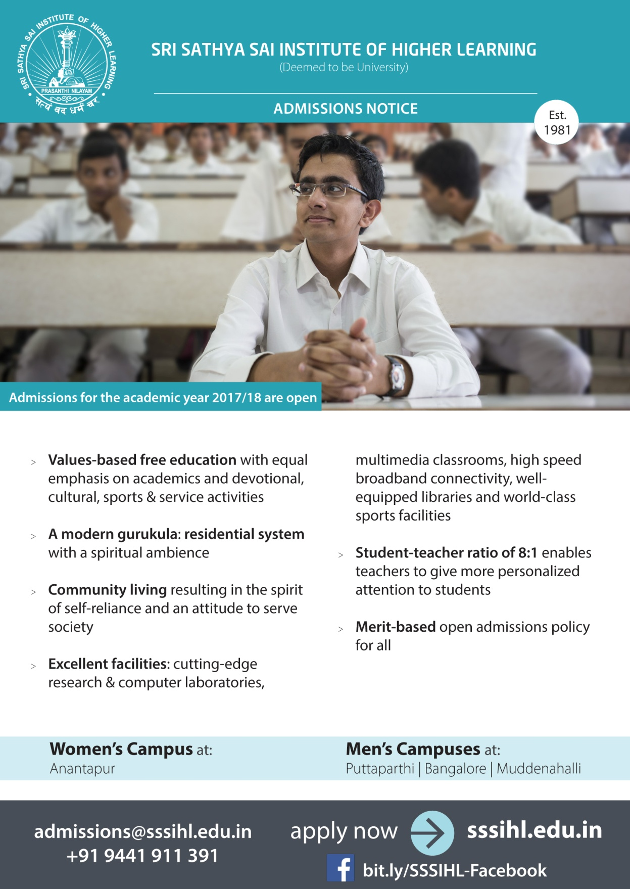

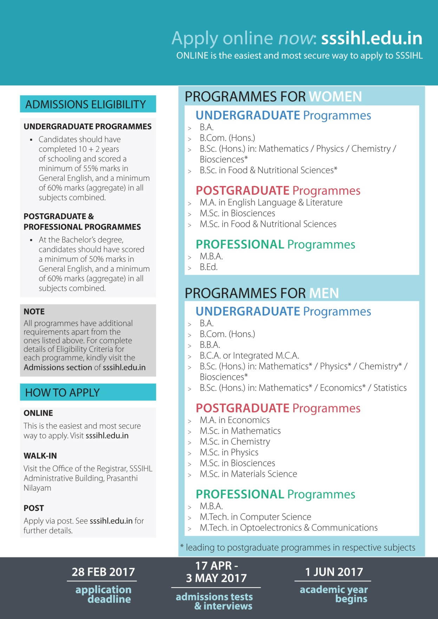

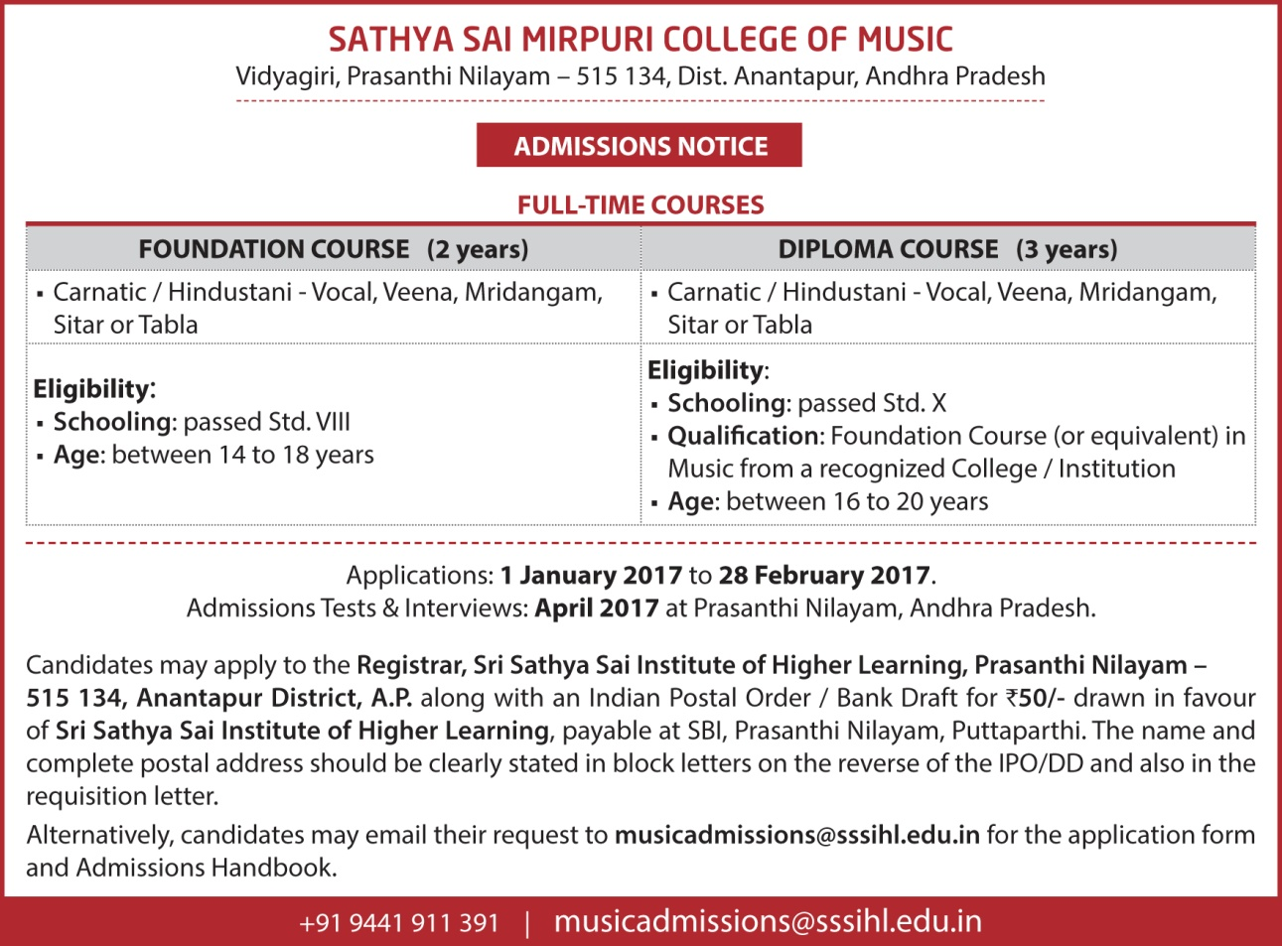

Sri Sathya Sai Higher Secondary School
Vidyagiri, Prasanthi Nilayam, Anantapur District, Andhra Pradesh - 515134
E-mail: ssshss@gmail.com, Phone No: 08555-289289

Admissions to Class I (Boys & Girls) and Class XI (Boys & Girls) for academic year 2017-18 will take place in June 2017. The medium of instruction will be English and the school is wholly residential.
Admission criteria for Class I ** Age Limit: 5½ years to 6½ years as on 30th September 2017. (Duplicate copy of Date of birth certificate – “issued by competent authority” shall be produced). The Date of Birth should be between 30-03-2011 and 30-03-2012
** Selection through random selection method
Admission criteria for Class XI Only English Medium students are eligible to apply.
Prospectus and Application forms Prospectus and Application forms can be obtained from 1st January 2017 onwards till 31st January 2017 either from the office of “Sri Sathya Sai Higher Secondary School, Prasanthi Nilayam, Puttaparthi” - by paying cash `100 /- (Timing:10 a.m. to 11 a.m. / 2.00 p.m. to 3.00 p.m. on all days except Sundays and holidays) (or) can be downloaded from our website: www.ssshss.edu.in The downloaded filled in application should be sent along with a Demand Draft drawn in favour of “Principal, Sri Sathya Sai Higher Secondary School” on State Bank of India, Puttaparthi Branch (Code no: 2786) for the value of `100/- with self-addressed envelope (Size: 15 cm x 24 cm). The last date for submission of filled in application form will be 15-02-2017.
– Principal

Direct your Love Towards God

Love is like the mariner’s compass, which always points to the north. At any time, any place or in any circumstance love points only towards God. Hence, everyone should try to understand how the love principle works. Love can be compared only with love. Prema (love) and Anuraga (affection) are one and the same. But affection, when it is directed towards worldly objects, gets tainted. Because of this pollution, joy and sorrow ensue. Man becomes a prey to desires and disappointments. However, when love is directed towards God, it becomes pure, selfless, enduring and divine.
– Baba

